Augmented Reality System and App

Description
By the customer’s point of view, system is used with a smartphone. Smartphone sends data to backend server for database storage and calculations which will eventually get brought back for viewing with smartphone.
Requirements Engineering

Feasibility Study
- Are there systems and apps similar to this in the marketplace? Identify 4 examples. (in Android, iOS, Windows …)? (min 100 words)

Main idea is to let the user browse different clothing items and see how they would look like on the user. Similar augmented reality -clothing apps can already be found in Google Play store. Such as:
1. LCST – Lacoste AR mobile app let’s the user to see how Lacoste shoes would look like in their feet.
2. London Magic Mirror. Big screen mirrors clothing on the user
3. Timberland augmented Reality. Same idea as London mirror.
4. Topshop also has copied the same idea.

These are clumsy and only usable in stores. Only the Lacoste app can be used on mobile device.

- Identify the main the main system features and services provided in an AR system. Consider existing systems and the services they provide to stakeholders.
[Reference and copy the URLs] (min 200 words)
In order to provide desired services, system will include (mobile) app, database for clothing items, and server where database will be stored (due to it’s supposed large size) and where logic and calculations will be made. Augmented reality apps will most likely need machine learning to recognize user’s body parts and heavy calculations to insert clothing items to their right place.

While taking closer look to Lacoste Ar mobile app,
https://www.enginecreative.co.uk/portfolio/lacoste-lcst-augmented-reality-retail-campaign/
it is easy to see that such services are not easy to offer. On the video from the website test subjects would not move their legs at all, possibly to prevent any malfunctions in the app but these are just speculations.

https://www.teenvogue.com/story/zara-augmented-reality-shopping-app
Zara takes a different approach. This app does not let the user see how the outfit would look like on them but adds a model in the surroundings where user points camera. More likely than not the system consists similar structure. These calculations are not possible to do on mobile phones.

- In what ways do stakeholders currently use such a system? (min 100 words)

At the moment only a few companies have tried to adapt this new technology for marketing purposes. Some, like Lacoste, claim that AR apps have increased their clientele, especially in the younger population.

Thousands of installations suggest that customers are at least interested what this new technology can offer to them. Customer only has to download the free app and start using it which also increases the interest.

But only for the developers the technology is the main thing. For every other stakeholder it is merely a tool to be used to increase sales or get a look at the product.
- Describe a new type of basic version of a system and how it might operate. Based on existing systems that provide services stakeholders. Use the internet to identify.

New system would rely heavily on the same kind of technology as used in Recognition based technology. System would be first taught basic shapes of human body. Mobile phone’s camera would feed constantly data to database for calculations where data would be compared to previously known shapes.

After that 3D images of the target subject as well as clothing items would be made and fitted together (and brought back to mobile app).

- Who are the stakeholders? Would this app affect them positively or negatively? (min 30 words)

Developers – positively since it brings jobs
Companies – positively if the product increases sales, negatively if sales won’t cover up expenses from ordering/developing/maintaining the app
Customers – positively because they get to “test” products where ever they may be

- Use a mind map to identify an initial list of functional requirements
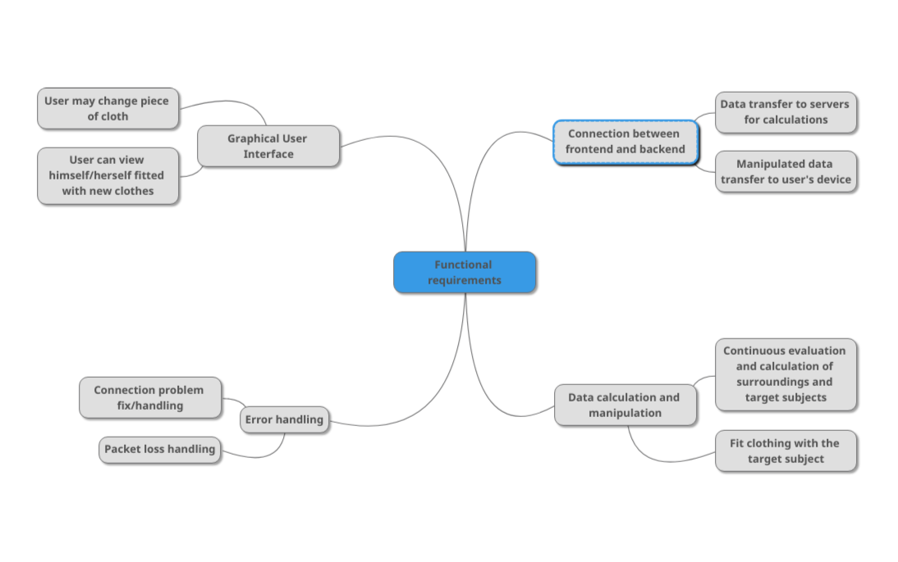

- Write an initial list of functional and non-functional requirements.

Functional requirements:
- Authentication
- Graphical user interface
- Connection to backend servers
- Data transfer back and forth
- Continuous evaluation and calculations of surroundings
- Error handling (lost data packets / connection)

Non-functional requirements:
- Security – username and password
- Performance – data should be sent back to user under 1 second
- Usability – clear giu
- Data integrity – data should be verified to be accurate before returning it to the user device
- Capacity – heavy calculations may require lots of computing power and memory

- What other research would be necessary to ascertain feasibility e.g., ownership of smartphones/tablets, on line shopping …? (min 100 words)

The idea of the app is to make virtual shopping and cloth fitting easier for normal consumer and for regular smartphone user. Thus owning some kind of smart device, be it phone or tablet, is necessary.
Also performance researches are required. Even though all the heavy lifting are supposed to be calculated on the server side, processing that data could prove to be demanding. And continuous internet connection could be necessary. Either that or then download assets from the server before displaying them to the user. That approach would demand more storage space and possibly even more computing power from the user’s device.

Requirements Elicitation

- Identify significant stakeholders, which will be interviewed to get more information on the intended product. Justify your choice of stakeholder(s). Do up an interview plan and pre-prepare approximately 10 questions.
Most important stakeholders, customers:
- Do you use apps on your smartphone or tablet? (Get the baseline for potential markets)
- Have you ever imagined needing similar kind of app?
- Is it something you could imagine paying for?
- Do you do any sports? (Leading question)
- What kind of clothing would you mostly test? (On what items the app should emphasize)
- Are there any specific companies whose clothing you would like to test? (Possible business partners)
- How do you feel making reservations and/or paying with your mobile devices on an app? (Possible future for the app)
- What features you would expect from an app like this?

- Identify a significant group of stakeholders, which will receive questionnaires. Justify your choice of stakeholders. The questionnaire that you create should have approximately 10 questions.

Developers, which are responsible for the end product:
- How would you build the system needed?
- In what programming languages would you accomplish this app?
- Do you think the system has weak points or flaws? What?
- Do you think it’d be wiser to rent servers or have own?
- Should we focus on one platform from the start?
- How big dev group would be needed?
- Estimate the release year/month.
- How prone to errors is a app this scale?
- How you think this app could expand in the future?
- Would you use this product yourself?

Requirements Analysis

- Use the use case template to analyse the proposed system

Draw an initial use-case diagram with supporting scenario description for this app (possibly using StarUML for the diagram). The first iteration of the use-case diagram can consist of a single overall use case with supporting main flow and 2 or 3 exception flows.

System Name
Clothing fitter
1. Try on clothes with the mobile app
Actor
Customer

USE CASE |  | 1. | Try on clothes with mobile app
Description of Goal in Context |  | The user will be able to use smartphone to visualize how some clothing would fit and look like.
Preconditions |  | The user owns a smartphone (with a camera) and has downloaded the app.  Database already includes clothing items.
Post Conditions, Success End Condition |  | The user can view oneself fitted with new clothing.
DESCRIPTION |  | The user uses smartphone to take a video of a himself/herself or some other person. Data is sent to servers and then sent back fitted with different clothing. The user can now view himself/herself from smartphone screen with new clothing.
Main Flow
Step | Action |  |  | Alternate
n.1.1 | User downloads the app and opens it.
n.1.2 | System creates connection between phone and servers.
n.1.3 | System offers different clothes to try on.
n.1.4 | System opens camera’s video feed and sends data to servers.
n.1.5 | System calculates target size and position and fits clothes on top of the target.
n.1.6 | System sends modified data to user’s phone.
n.1.7 | System offers option to select new piece of cloth or to quit the app.
n.1.8 | End use case.
EXCEPTIONS or ERROR Flow Description
Step | Branching Action  < Exception number m of Use Case n> |  |  | Alternate
1.2.1 | User has no internet connection  System tries to make the connection between phone and servers. Limited to 5 re-connection attempts.
1.2.2 | Connection made: go to MF 1.3.  Connection failed: Exit the app with user message to check connection and start the app again. END USE CASE.
1.4.1 | System doesn’t have permission to use end device’s camera  System demands the permission.
1.4.2 | Permission not granted: Urge the user to give permission in the settings. Otherwise exit the app. END USE CASE.  Permission granted: Go to MF 1.4

Non-functional requirements, management issues and decisions required to be made, can be identified in the following table

RELATED INFORMATION | Use Case: 1 | Try on clothes with mobile app PERFORMANCE
Priority: | Critical
Performance | <the amount of time this use case should take>
Frequency | Frequent at start
Channels to actors | <e.g. interactive, static files, database, timeouts>
OPEN ISSUES | <list of issues awaiting decision affecting this use case>
Due Date | <date or release needed>

- Draw a second iteration consisting of 4 or 5 use cases. Each use case requires a use case narrative describing the scenario analysis. Each use case should have 2 or 3 exception or alternative flows. (These can be written in a separate word document)
SEE UseCases_AtteKarppinen.docx

Requirements Specification

- From the requirements analysis identified using the use Case scenario analysis identify key functional requirements.
Fill up the following matrix with functional requirements.

Req ID | Name of Req | Description | Priority | User Contact

System Modeling

- Identify the Actors and additional possible actors in this system?

- Identify the Use cases and the possible additional use-cases in this system?

Verification and Validation of Requirements

- Test Case Planning.
Put one sample test case in this section.

(Additional test cases are required in section 21 and 22 and can be written in a separate test case word document)

Identify the User Acceptance Testing requirements for the use cases identified in Iteration 2 of the Use Case Analysis

Use the test case template to create initial Use Acceptance Test plans that will permit users and developers to agree the system will have been developed as specified by the requirements

Consider the test plan as a user guide or user manual for non-technical novice users of the system

Test Case Number:
Test Case Name:
Related Use Case Name: Number:

Purpose:
Procedure Steps: (Guided by Main flow or other flows of Use case)

Expected Results:

Completing the Feasibility Study

- Before you do the final submission of the feasibility report, review and update your previous submissions.
  - Modify the requirements Specification list to high level (Abstract) core system features

Update Use-Case Model and Requirement Specification

- Consider the Use case Model to be sure key functionality has been addressed in the analysis and modelling process.
  - Do any of your use-cases need to be broken down further i.e., is there is too much functionality in one use-case?
  - Update the Use Case Model as necessary.
  - Update your RS with abstracted requirements as necessary.
  - In your RS, put in a new column which shows what use-cases are related to which requirement.

Prototype
- Sketch the home page/starting page of the app. You should take a photo of it and insert the photo into the document.

User Manual
- Develop an initial version of a User manual for the system. This is to be developed in a separate word document.

Additional Functional & Non-Functional Test-Cases

- Write three additional test-case (using the test-case template) for each of three abstracted high priority functional requirements (one test-case per requirement/use case).

- Write two test-case (using the test-case template) for each of the two most important non-functional requirements (one test-case per requirement).

